CSIS 3275 Software Engineering

Project Report (Group #3)

Parteek Saini 300323311

Jagseer Singh 300323885

Shubam Kalra 300323868

**1.Program Coding: -** Project is working fine with desired output and having no errors. We created our project with the help of JavaFX to display the window-based application. In our application we have the main package which is named as “sample” and under this package we have controller classes such as Battleship and FXMLDocumentController. Under the sample package we have two package which are representing the model and view of the program. This model and view package are being accessed by FXMLDoument class. Here is the below diagram, which is representing the relationship among packages and classes.

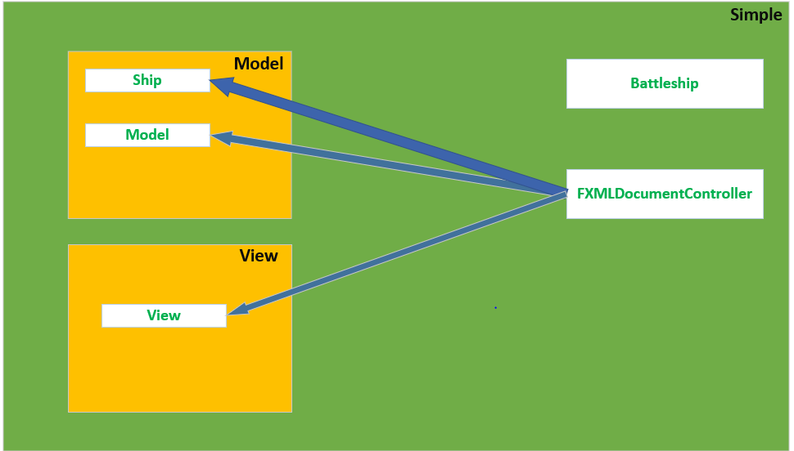

**2.Program Features Added: -** We have added some more features to our application, which are listed below.

1. Timer: This is a basic feature in which a timer will start at first fire of the game and it will run until the game is finished that is until all the ships has been sunk.
2. Pause/Resume Button: This feature allows user to Pause the game whenever they want to hold the current state of game. When Pause button is clicked, the running timer will pause and fire button will become disabled, and text of Pause Button will change into Resume Game. Furthermore, when Resume button is clicked, then Timer will resume, and fire button will become enabled, and text of Resume Game button will change into Pause Game.
3. Reset Game: This button allows user to quit the ongoing game and start a new game. When this button is clicked then running window will be closed and a new window will open with a new game.

**3. Output of program.**

1. When program is run:(Opening Window)

1. After firing some shots:

1. After clicking Pause button:

1. After Clicking Resume Button:

1. After Completing the game:

1. After clicking the Reset Game Button:

